CZ1106 Tutorial TWO

Addressing Modes, Assembly Programming

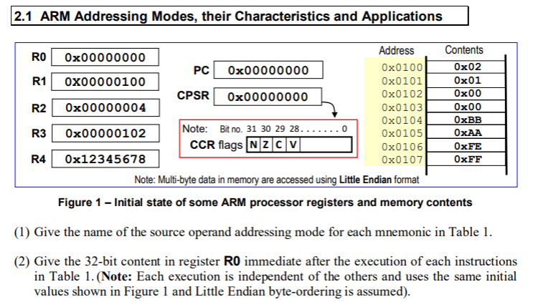



|  |  |  |  |
| --- | --- | --- | --- |
| No | Mnemonics | Source addressing mode | Content in R0 |
| 1 | MOV R0, R2 | Register direct ✅ | 0x0000 0004 |
| 2 | MOV R0, #0x100 | Immediate value ✅ | 0x1000 0000 |
| 3 | LDR R0, [R1] | Register indirect ✅ | 0x0000 0102 |
| 4 | LDR R0, [R1, #4] | Register indirect with offset ❌ base + offset (pre-index) | 0xFFFE AABB |
| 5 | LDR R0, [R1, R2] | Register indirect with index register ❌ base + index register (pre-index) | 0xFFEE AABB |
| 6 | LDR R0, [R1, #4]! | Register indirect with immediate value pre-autoindexing ✅ | 0xFFEE AABB |
| 7 | LDR R0, [R1], #4 | Register indirect with immediate value post-autoindexing ✅ | 0x0000 0102 |
| 8 | LDR R0, [R1, R2]! | Register indirect with index register pre-autoindexing ✅ | 0xFFFE AABB |
| 9 | LDR R0, [R1], R2 | Register indirect with index register post-autoindexing ✅ | 0x0000 0102 |

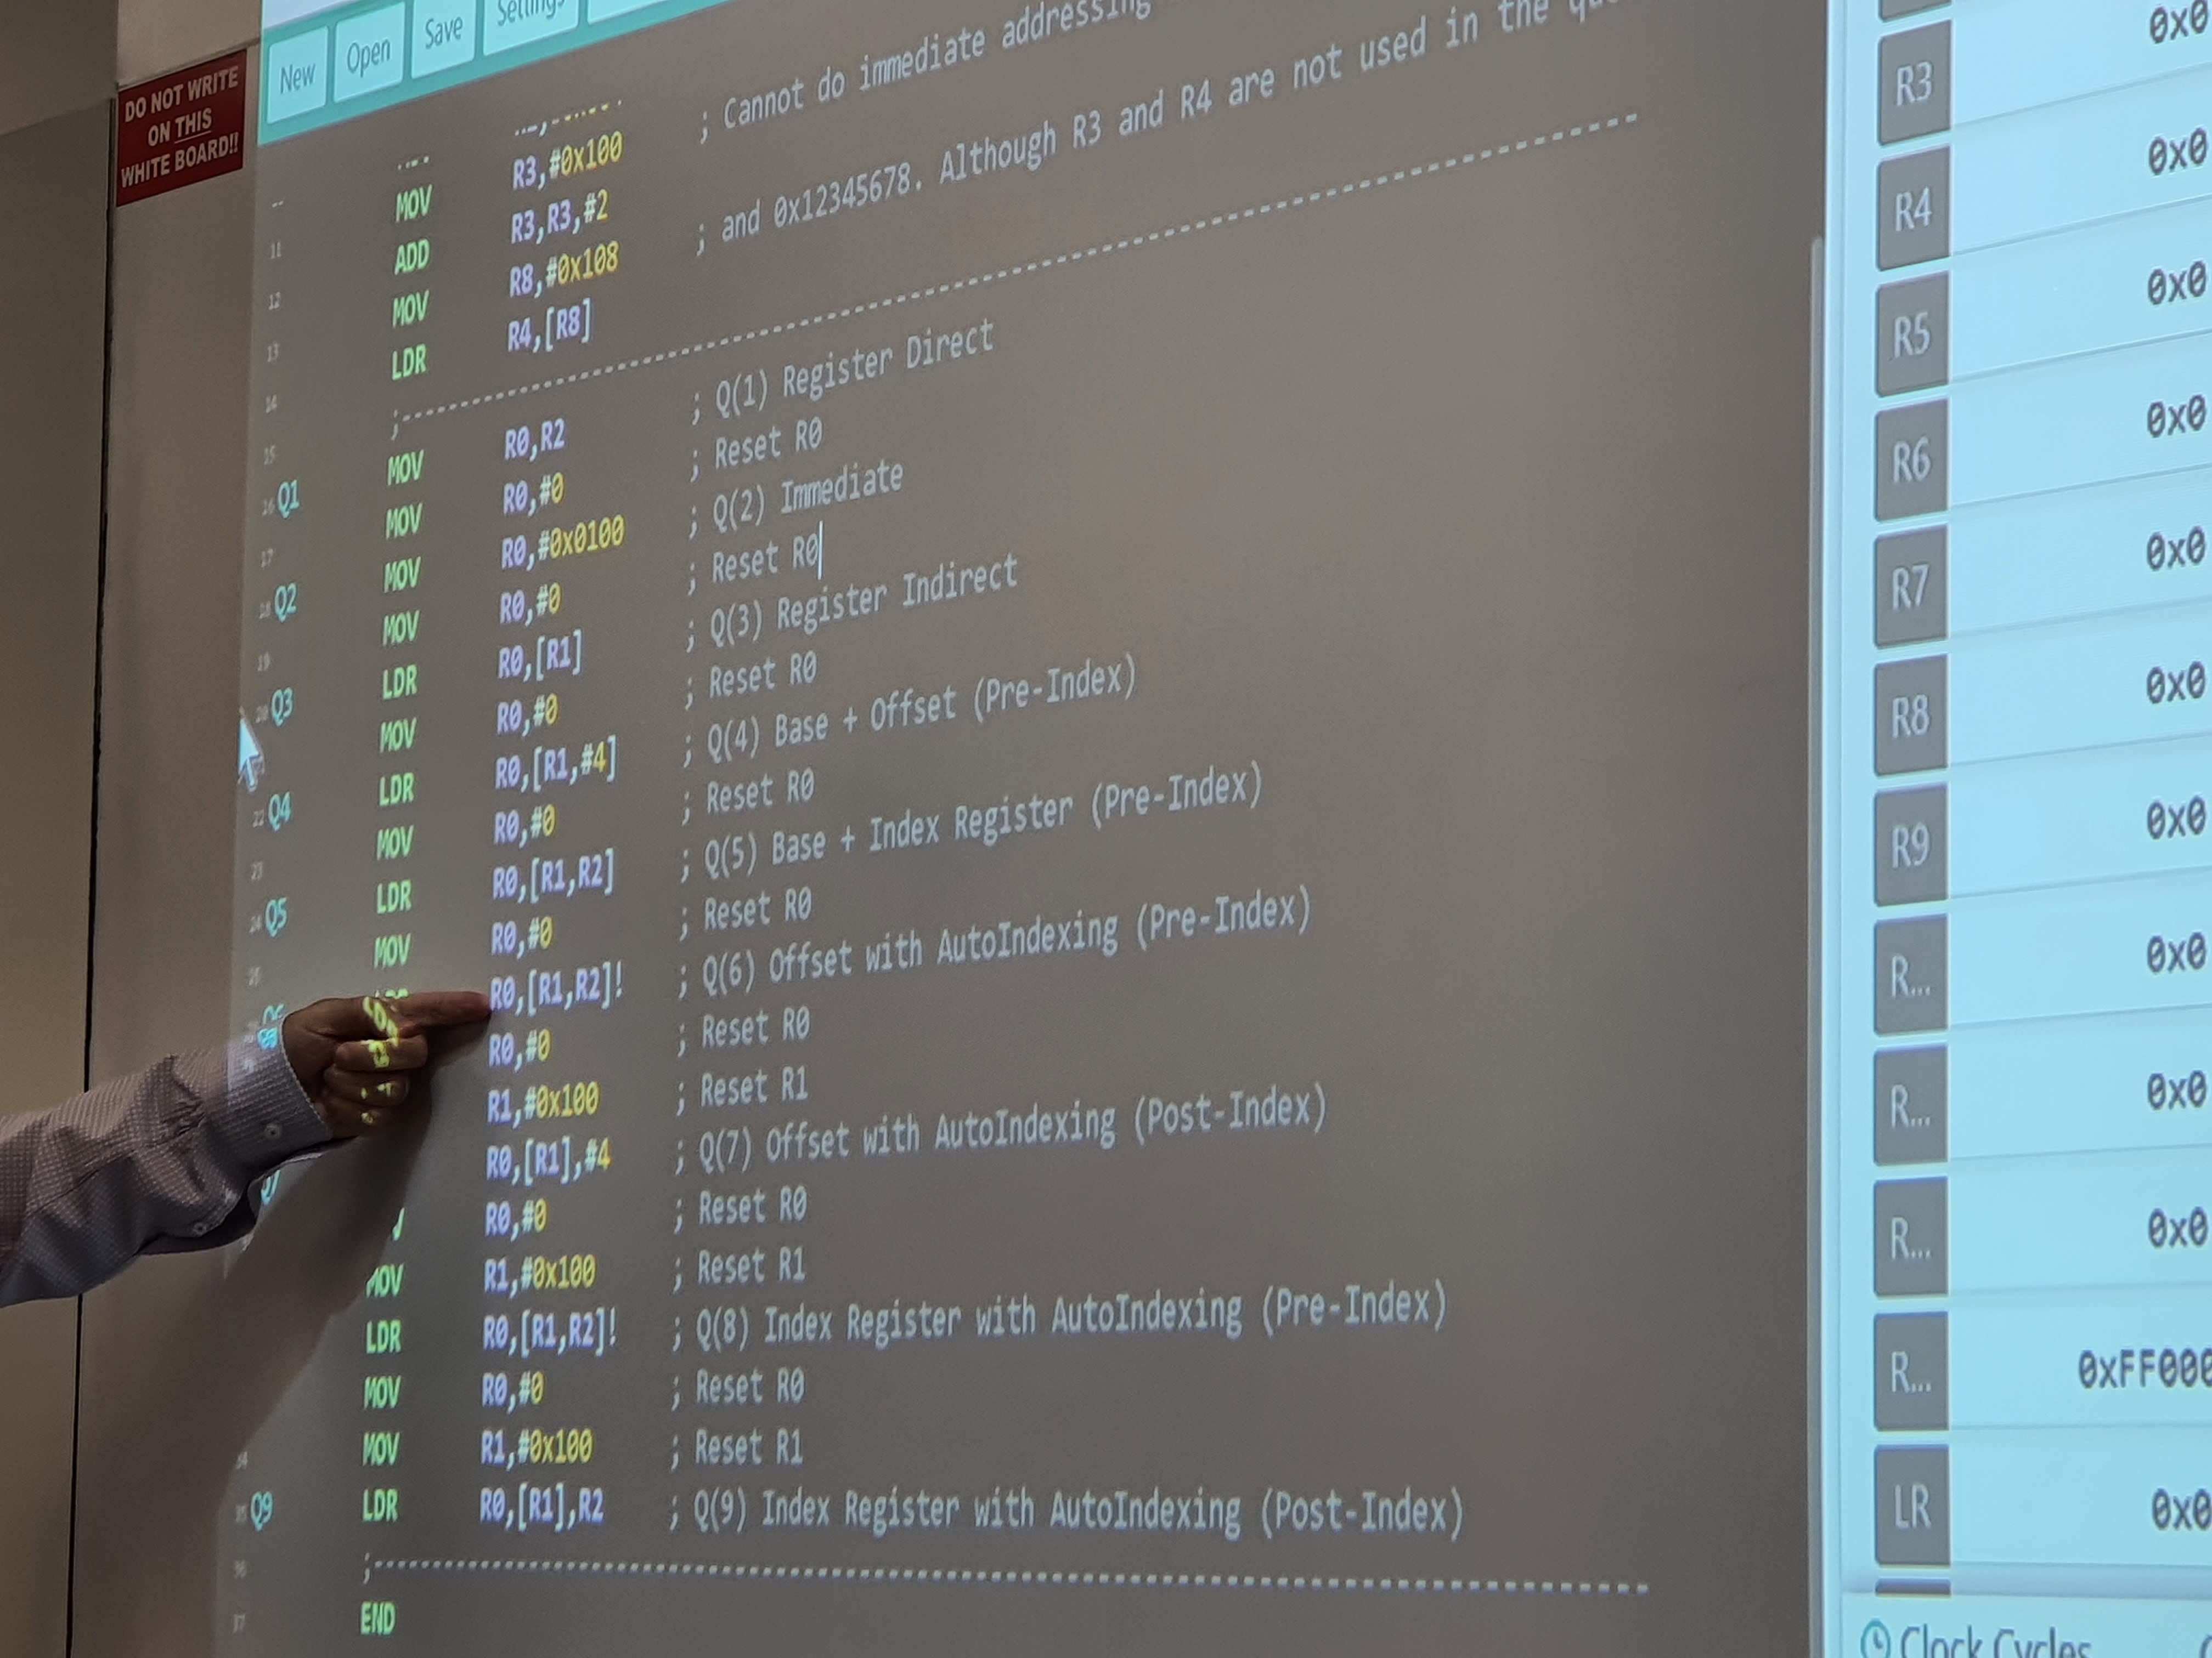

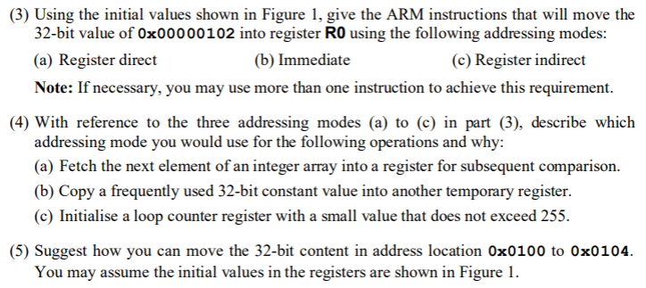

a) MOV R0, R3 ✅

b)

MOV R0, #0x100

ADD R0, R0, #2 ✅

c) MOV R0, [R1] ❌LDR R0, [R1]



a) Register indirect

b) Register direct

c) Immediate



32 bit = 4 byte = 0x0100 to 0x0103.

MOV R0, 0x0100

loop 4 times:

LDR R1, [R0] ;R1 stores the byte to be transported

STR R1, [R0, #4]

ADD R0, R0, #1

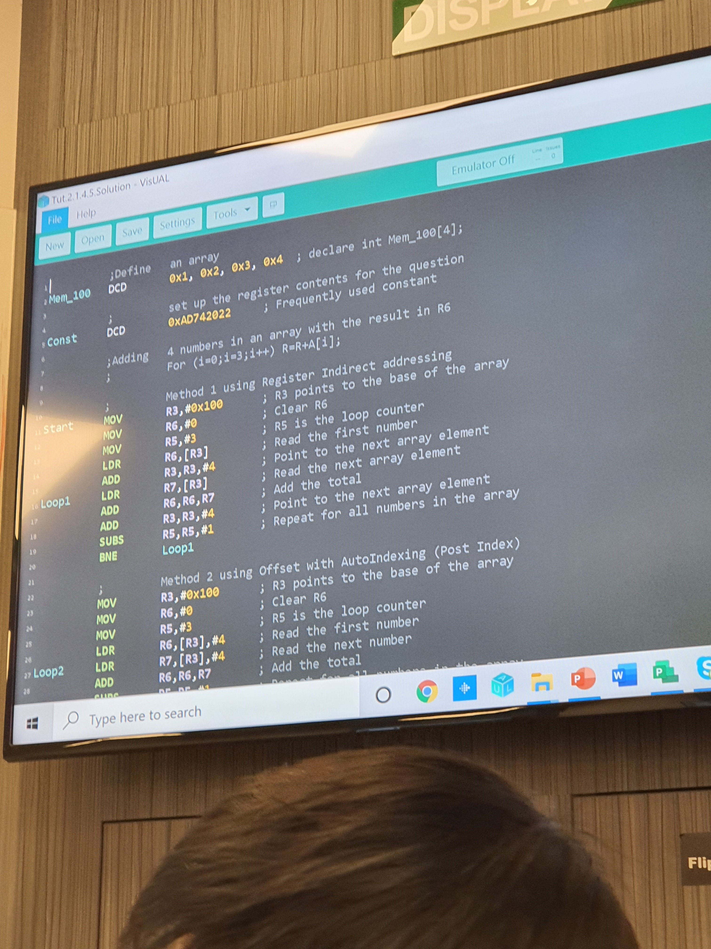

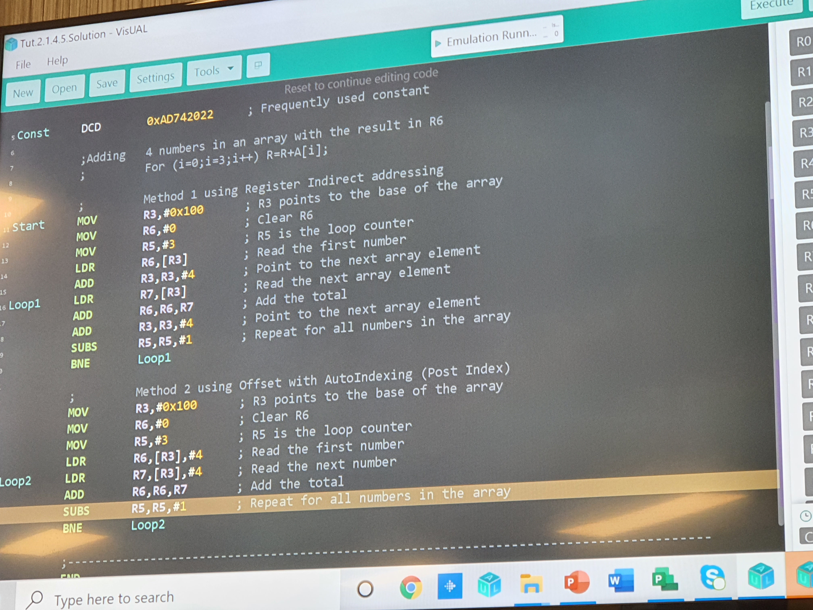

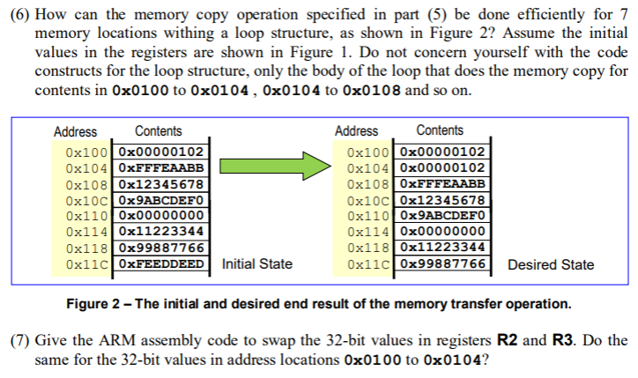

MOV R0, 0x100

LDR R1, [R0] ;store data to move

loop:

LDR R2, [R0, #4]! ;store next data to displace into R2

STR R1, [R0] ;move data in from R1

LDR R1, [R0, #4]! ;store next displacement data into R1 (override)

STR R2, [R0] ;move data in from R2

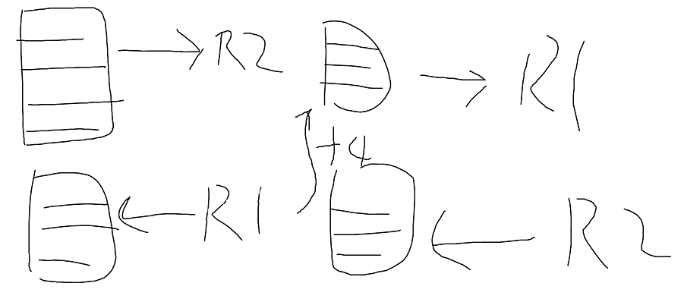



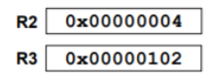

MOV R1, R2

MOV R2, R3

MOV R3, R1

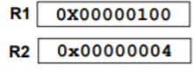

LDR R0, [R1] ;R0 must go into 0x104

